Gender equity in sports; Is equal prize money at equivalent events fair?

Since the last century sports have taken a crucial place in our society, mostly because they turned out into a profitable business for people around them. But also, because sports have become a tool to shape society. A great example of this occur when the equity gender concept started to grow during the 70’s, at that time society (or who was in charge to assign salaries) thought that women should ear less than men because they weren’t ‘as good as their male peers. To proof this idea wrong, a tennis court turned out to be the perfect arena, the ‘Battle of sexes” in 1973 was a tennis match between Bobby Riggs and Billy Jean King that proved to million viewers that women were as capable as men performing athletic skills. That day Billy Jean King won and started a fight for equal pay for men and women on sport events.

Nowadays most of the sports still have an unequal pay, just think at soccer or golf, (the gap is insane!!!) although some sports as tennis, badminton or squash are trying to close this gap providing in some events same prize money for men and women.

Even though this should look like an effort unanimously celebrated, not everyone agrees with it; a couple of weeks ago Novak Djokovic said that men should earn more money than women players at because they attracted more people to watch the sport.

The logic of Djokovic might be right for a sales business, but not for sports, as a tennis player he is sort of a ‘contractor’ of the ATP, and his pay is according to the place he finishes at competitions, not how many people watch him smiling at the camera or wiping his face with a towel (sponsors are the ones that should pay for that)

Since most individual sports have the same format of tournaments and ranking systems I decided to analyse squash data to find out what is an equivalent pay for men and women. The analysis can be extended to similar sports.

For the analysis below I decided to use extracted the data from the 2017 April PSA Rankings and I assume two things:

Is equally difficult to be No 1 in the men’s rankings as in the women’s rankings.

Being last on the rankings requires no effort.

The rankings are assigned according to the average points earned during the last 12 months. Is natural to use the standardized average points as a measurement of effort. The following charts shows the effort required to be at a certain ranking for men and women. The logarithmic transformation shows the same information but emphasising the difference on crucial sports (Warning: Objects in the logarithmic chart distorts the distance between them).

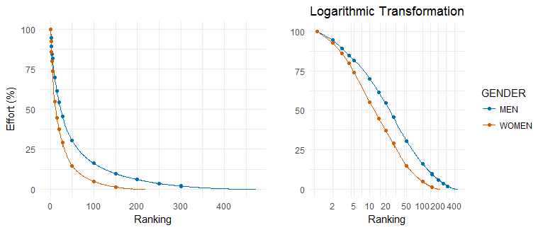

From this chart, we can see that it requires almost the same amount of effort to be at the top positions, but as soon as the ranking start dropping, the effort required for men is higher. This happens mainly because there are more men than women in the rankings. This fact is crucial but doesn’t tell the whole story.

This chart can help to find equivalent rankings between male and female players.

On the chart below I want to show 3 methods that could be used to find equivalent rankings between both genders.

Effort.- This method matches the effort required for every ranking according to the previous analysis

Naïve.- This method assumes parity between both rankings, although this is unrealistic due different population sizes it a useful reference tool.

Active players. - This method divides the rank according to the number of active players

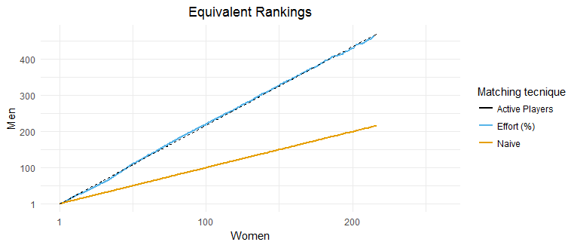

The chart shown above shows that the effort and the active players methods are almost equivalent, but the way they compare the top 10 is not the same. Zooming in at the plot you can see that the closer it gets to the No 1 the active player method gets closer to the Naïve method. This means that for the number of players in both rankings, women are more competitive on the race to the top than men.

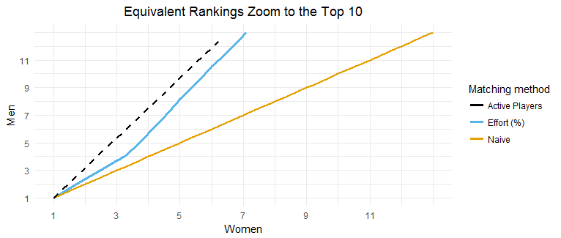

The table below shows the ranking equivalency for men and women according to each method.

Now looking at the table below is possible to compare and find how each strategy pair each ranking.

Then if the goal is to make sure that you get paid properly despite the gender then you should make sure that equivalent rankings make the same amount in a whole year.

Women Effort.... Active.Players Naive

1 1 1 1 1

2 2 2 3 2

3 3 4 5 3

4 4 6 8 4

5 5 8 10 5

6 6 11 12 6

7 7 13 14 7

8 8 15 16 8

9 10 20 21 10

10 20 38 42 20

11 26 50 56 26

12 46 100 100 46

13 50 109 108 50

14 90 200 196 90

15 100 220 216 100

Now it’s important to find if players with equivalent rankings play similar amount of tournaments.

According to the rules, average points are assigned differently for men and women. For men, are assigned in the following way, if you had played 13 tournaments or less, they add the points of your 10 best tournaments and divided by 10, if you have played 14 tournaments they divided by 11 and so on. For women if you have played 10 tournaments or less they consider your best 8.

This rule seems logical if you consider that there should be a direct relation between the number of players on the tour and number of tournaments in a year. With this rule, it is natural to think that a male athlete plays more tournaments than a female athlete with an equivalent ranking.

Looking at the chart below is possible to see the difference of tournaments played by athletes with equivalent rankings. Performing a linear regression is possible to find that a woman plays 14% less tournaments than a man with an equivalent ranking.

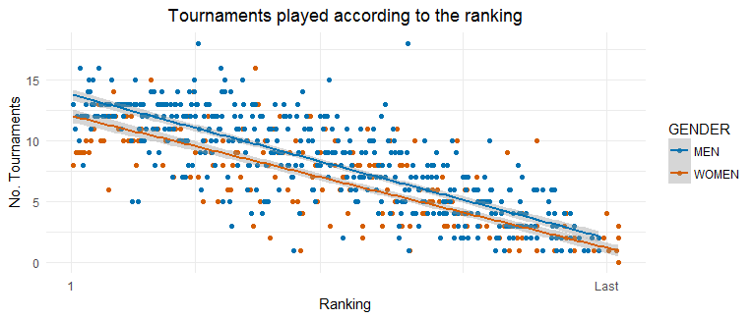

This means that to make sure that players with equivalent rankings make the same amount of money in a year is important to provide prizes for women 16% bigger than men so at the end of the year they can make similar amount of money.

This might lead you to think that women tournaments need to award more money than men tournaments, but that is not the case, remember that there are less women players.

To make things clear let’s take as an example the World Series Final Tournament, In this tournament only the best 8 players are allowed to play and the prize money breakdown is at follows:

Winner 30%

Runner-up 20 %

SF 12.5%

The total awarded for men and women is the same, this is a great idea towards equity pay but is not fair, unless you think that the Naïve matching method is true.

Considering that women play 14% less tournaments than men, and the Effort (%) matching method an equivalent prize money breakdown would be

Winner 30% 35%

Runner-up 20% 23%

SF 12.5% 11.5%

5/6 7.5% 4.5 %

7/8 5% 3 %

With this breakdown, you still have a 4% from the women prize unassigned, why? Because according to the equivalent rankings the effort of being rank between 3 to 8 is bigger for men than for women. Then the prize money for women should be 4% smaller than for men and the breakdown should end up like this.

Winner 30% 37%

Runner-up 20% 24%

SF 12.5% 12%

5/6 7.5% 4.5 %

7/8 5% 3 %

This approach might not look as appealing as the strategy of giving the same amount of money for men and women, but the biggest problem with equal pays is that the lady ranked as number 1 will make less money than the male athlete ranked as number 1 (assuming both were undefeated during the whole season) because she will play less tournaments.

If you have different rules and the population sizes are different you need different prize breakdown to make sure you reward the effort equally regardless the gender.

This analysis might turn out more accurate if data of previous ranking months were available.

Check the code on GitHub.